Went on Dataverse, created a dataset and uploaded 3 Images. Lastly, Publish the Dataset.

Ran a search: curl -s [http://localhost:8080/api/search?q=*](http://localhost:8080/api/search?q=*)

Result:

{"status":"OK","data":{"q":"*","total_count":6,"start":0,"spelling_alternatives":{},"items":[{"name":"image url testing","type":"dataset","url":"https://doi.org/10.5072/FK2/JXOJWO","image_url":"http://localhost:8080/api/datasets/4/logo","global_id":"doi:10.5072/FK2/JXOJWO","description":"test","published_at":"2024-10-21T19:47:56Z","publisher":"Root","citationHtml":"Admin, Dataverse, 2024, \"image url testing\", <a href=\"https://doi.org/10.5072/FK2/JXOJWO\" target=\"_blank\">https://doi.org/10.5072/FK2/JXOJWO</a>, Root, V1","identifier_of_dataverse":"root","name_of_dataverse":"Root","citation":"Admin, Dataverse, 2024, \"image url testing\", https://doi.org/10.5072/FK2/JXOJWO, Root, V1","publicationStatuses":["Published"],"storageIdentifier":"local://10.5072/FK2/JXOJWO","subjects":["Arts and Humanities"],"fileCount":3,"versionId":1,"versionState":"RELEASED","majorVersion":1,"minorVersion":0,"createdAt":"2024-10-21T19:47:39Z","updatedAt":"2024-10-21T19:47:56Z","contacts":[{"name":"Admin, Dataverse","affiliation":"Dataverse.org"}],"authors":["Admin, Dataverse"]},{"name":"bg,f8f8f8-flat,750x,075,f-pad,750x1000,f8f8f8.jpg","type":"file","url":"http://localhost:8080/api/access/datafile/6","image_url":"http://localhost:8080/api/access/datafile/6?imageThumb=true","file_id":"6","published_at":"2024-10-21T19:47:56Z","file_type":"JPEG Image","file_content_type":"image/jpeg","size_in_bytes":37201,"md5":"015ff22efb4b3882c96c076d31d9eaaf","checksum":{"type":"MD5","value":"015ff22efb4b3882c96c076d31d9eaaf"},"dataset_name":"image url testing","dataset_id":"4","dataset_persistent_id":"doi:10.5072/FK2/JXOJWO","dataset_citation":"Admin, Dataverse, 2024, \"image url testing\", https://doi.org/10.5072/FK2/JXOJWO, Root, V1","publicationStatuses":["Published"],"releaseOrCreateDate":"2024-10-21T19:47:56Z"},{"name":"harvard-university-logo-2F22CN9.jpg","type":"file","url":"http://localhost:8080/api/access/datafile/7","image_url":"http://localhost:8080/api/access/datafile/7?imageThumb=true","file_id":"7","published_at":"2024-10-21T19:47:56Z","file_type":"JPEG Image","file_content_type":"image/jpeg","size_in_bytes":55165,"md5":"a4f4debcd6a9997c3af5ba1ca8691aae","checksum":{"type":"MD5","value":"a4f4debcd6a9997c3af5ba1ca8691aae"},"dataset_name":"image url testing","dataset_id":"4","dataset_persistent_id":"doi:10.5072/FK2/JXOJWO","dataset_citation":"Admin, Dataverse, 2024, \"image url testing\", https://doi.org/10.5072/FK2/JXOJWO, Root, V1","publicationStatuses":["Published"],"releaseOrCreateDate":"2024-10-21T19:47:56Z"},{"name":"_1523460223_965_Harvard-Wreath-Logo_ab2ece9fbd52-desktop.jpg","type":"file","url":"http://localhost:8080/api/access/datafile/5","image_url":"http://localhost:8080/api/access/datafile/5?imageThumb=true","file_id":"5","published_at":"2024-10-21T19:47:56Z","file_type":"JPEG Image","file_content_type":"image/jpeg","size_in_bytes":155058,"md5":"6de0eaa18122b3443835a838310d24ee","checksum":{"type":"MD5","value":"6de0eaa18122b3443835a838310d24ee"},"dataset_name":"image url testing","dataset_id":"4","dataset_persistent_id":"doi:10.5072/FK2/JXOJWO","dataset_citation":"Admin, Dataverse, 2024, \"image url testing\", https://doi.org/10.5072/FK2/JXOJWO, Root, V1","publicationStatuses":["Published"],"releaseOrCreateDate":"2024-10-21T19:47:56Z"},{"name":"Dataverse Admin Dataverse","type":"dataverse","url":"http://localhost:8080/dataverse/1b","identifier":"1b","description":"test","published_at":"2024-10-08T20:59:25Z","publicationStatuses":["Published"],"affiliation":"Dataverse.org","parentDataverseName":"Root","parentDataverseIdentifier":"root"},{"name":"Dataverse Admin Dataverse","type":"dataverse","url":"http://localhost:8080/dataverse/1a","identifier":"1a","published_at":"2024-10-08T20:59:45Z","publicationStatuses":["Published"],"affiliation":"Dataverse.org","parentDataverseName":"Dataverse Admin Dataverse","parentDataverseIdentifier":"1b"}],"count_in_response":6}}%

Unrestricted Image – was able to download and view the image

Ran: curl -s [http://localhost:8080/api/search?q=*](http://localhost:8080/api/search?q=*)

Result:

{"status":"OK","data":{"q":"*","total_count":6,"start":0,"spelling_alternatives":{},"items":[{"name":"image url testing","type":"dataset","url":"https://doi.org/10.5072/FK2/JXOJWO","image_url":"http://localhost:8080/api/datasets/4/logo","global_id":"doi:10.5072/FK2/JXOJWO","description":"test","published_at":"2024-10-21T19:47:56Z","publisher":"Root","citationHtml":"Admin, Dataverse, 2024, \"image url testing\", <a href=\"https://doi.org/10.5072/FK2/JXOJWO\" target=\"_blank\">https://doi.org/10.5072/FK2/JXOJWO</a>, Root, V1","identifier_of_dataverse":"root","name_of_dataverse":"Root","citation":"Admin, Dataverse, 2024, \"image url testing\", https://doi.org/10.5072/FK2/JXOJWO, Root, V1","publicationStatuses":["Published"],"storageIdentifier":"local://10.5072/FK2/JXOJWO","subjects":["Arts and Humanities"],"fileCount":3,"versionId":2,"versionState":"RELEASED","majorVersion":1,"minorVersion":1,"createdAt":"2024-10-21T19:47:39Z","updatedAt":"2024-10-21T19:57:11Z","contacts":[{"name":"Admin, Dataverse","affiliation":"Dataverse.org"}],"authors":["Admin, Dataverse"]},{"name":"bg,f8f8f8-flat,750x,075,f-pad,750x1000,f8f8f8.jpg","type":"file","url":"http://localhost:8080/api/access/datafile/6","file_id":"6","published_at":"2024-10-21T19:47:56Z","file_type":"JPEG Image","file_content_type":"image/jpeg","size_in_bytes":37201,"md5":"015ff22efb4b3882c96c076d31d9eaaf","checksum":{"type":"MD5","value":"015ff22efb4b3882c96c076d31d9eaaf"},"dataset_name":"image url testing","dataset_id":"4","dataset_persistent_id":"doi:10.5072/FK2/JXOJWO","dataset_citation":"Admin, Dataverse, 2024, \"image url testing\", https://doi.org/10.5072/FK2/JXOJWO, Root, V1","publicationStatuses":["Published"],"releaseOrCreateDate":"2024-10-21T19:47:56Z"},{"name":"harvard-university-logo-2F22CN9.jpg","type":"file","url":"http://localhost:8080/api/access/datafile/7","image_url":"http://localhost:8080/api/access/datafile/7?imageThumb=true","file_id":"7","published_at":"2024-10-21T19:47:56Z","file_type":"JPEG Image","file_content_type":"image/jpeg","size_in_bytes":55165,"md5":"a4f4debcd6a9997c3af5ba1ca8691aae","checksum":{"type":"MD5","value":"a4f4debcd6a9997c3af5ba1ca8691aae"},"dataset_name":"image url testing","dataset_id":"4","dataset_persistent_id":"doi:10.5072/FK2/JXOJWO","dataset_citation":"Admin, Dataverse, 2024, \"image url testing\", https://doi.org/10.5072/FK2/JXOJWO, Root, V1","publicationStatuses":["Published"],"releaseOrCreateDate":"2024-10-21T19:47:56Z"},{"name":"_1523460223_965_Harvard-Wreath-Logo_ab2ece9fbd52-desktop.jpg","type":"file","url":"http://localhost:8080/api/access/datafile/5","image_url":"http://localhost:8080/api/access/datafile/5?imageThumb=true","file_id":"5","published_at":"2024-10-21T19:47:56Z","file_type":"JPEG Image","file_content_type":"image/jpeg","size_in_bytes":155058,"md5":"6de0eaa18122b3443835a838310d24ee","checksum":{"type":"MD5","value":"6de0eaa18122b3443835a838310d24ee"},"dataset_name":"image url testing","dataset_id":"4","dataset_persistent_id":"doi:10.5072/FK2/JXOJWO","dataset_citation":"Admin, Dataverse, 2024, \"image url testing\", https://doi.org/10.5072/FK2/JXOJWO, Root, V1","publicationStatuses":["Published"],"releaseOrCreateDate":"2024-10-21T19:47:56Z"},{"name":"Dataverse Admin Dataverse","type":"dataverse","url":"http://localhost:8080/dataverse/1b","identifier":"1b","description":"test","published_at":"2024-10-08T20:59:25Z","publicationStatuses":["Published"],"affiliation":"Dataverse.org","parentDataverseName":"Root","parentDataverseIdentifier":"root"},{"name":"Dataverse Admin Dataverse","type":"dataverse","url":"http://localhost:8080/dataverse/1a","identifier":"1a","published_at":"2024-10-08T20:59:45Z","publicationStatuses":["Published"],"affiliation":"Dataverse.org","parentDataverseName":"Dataverse Admin Dataverse","parentDataverseIdentifier":"1b"}],"count_in_response":6}}**%**

image_url not displayed

Regression:

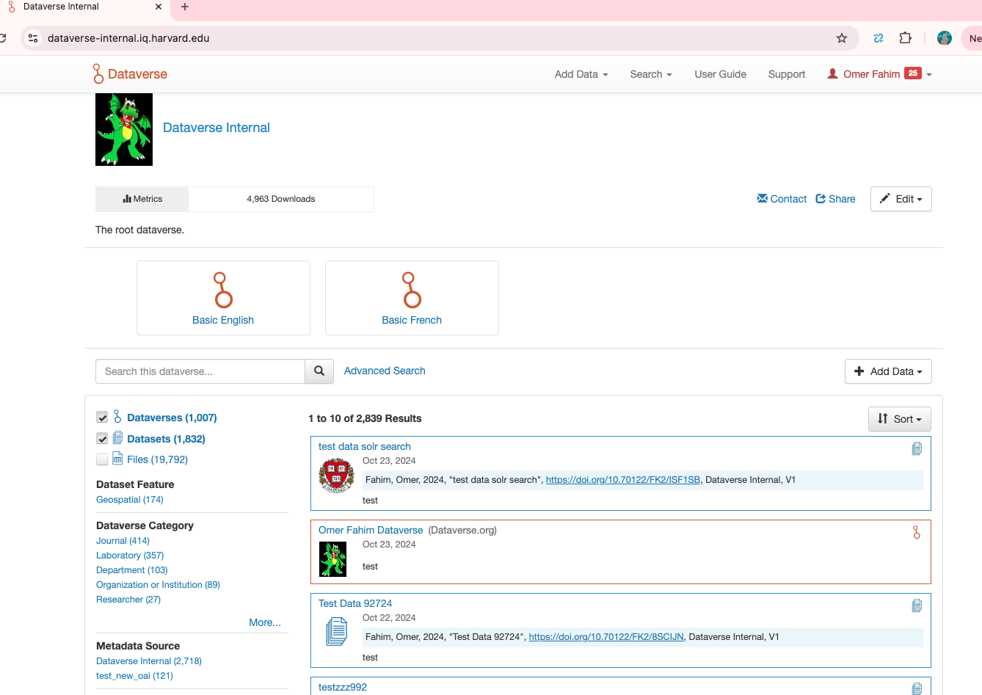

Run: curl -s [https://dataverse-internal.iq.harvard.edu/api/search?q=*](https://dataverse-internal.iq.harvard.edu/api/search?q=*)

{"status":"OK","data":{"q":"*","total_count":11269,"start":0,"spelling_alternatives":{},"items":[{"name":"dv1_1","type":"dataverse","url":"https://dataverse-internal.iq.harvard.edu/dataverse/dv1_1","identifier":"dv1_1","published_at":"2020-06-12T15:00:20Z","publicationStatuses":["Published"],"affiliation":"Dataverse.org","parentDataverseName":"dv1"},{"name":"dv1","type":"dataverse","url":"https://dataverse-internal.iq.harvard.edu/dataverse/dv1","identifier":"dv1","published_at":"2020-06-12T14:59:57Z","publicationStatuses":["Published"],"affiliation":"Dataverse.org","parentDataverseName":"Dataverse Internal"},{"name":"Local file1","type":"dataverse","url":"https://dataverse-internal.iq.harvard.edu/dataverse/localfile1","identifier":"localfile1","published_at":"2020-06-05T15:51:33Z","publicationStatuses":["Published"],"affiliation":"Dataverse.org","parentDataverseName":"Dataverse Internal"},{"name":"kc061120 kc061120 Dataverse","type":"dataverse","url":"https://dataverse-internal.iq.harvard.edu/dataverse/kc061120","identifier":"kc061120","published_at":"2020-06-11T14:49:03Z","publicationStatuses":["Published"],"parentDataverseName":"Dataverse Internal"},{"name":"kc060520 kc060520 Dataverse","type":"dataverse","url":"https://dataverse-internal.iq.harvard.edu/dataverse/kc060520","identifier":"kc060520","published_at":"2020-06-05T15:04:07Z","publicationStatuses":["Published"],"parentDataverseName":"Dataverse Internal"},{"name":"kc061620 kc061620 Dataverse","type":"dataverse","url":"https://dataverse-internal.iq.harvard.edu/dataverse/kc061620","identifier":"kc061620","published_at":"2020-06-16T15:49:20Z","publicationStatuses":["Published"],"parentDataverseName":"Dataverse Internal"},{"name":"dv5","type":"dataverse","url":"https://dataverse-internal.iq.harvard.edu/dataverse/dv5","identifier":"dv5","published_at":"2020-06-12T20:33:30Z","publicationStatuses":["Published"],"affiliation":"Dataverse.org","parentDataverseName":"Dataverse Internal"},{"name":"dv3","type":"dataverse","url":"https://dataverse-internal.iq.harvard.edu/dataverse/dv3","identifier":"dv3","published_at":"2020-06-12T17:01:49Z","publicationStatuses":["Published"],"affiliation":"Dataverse.org","parentDataverseName":"Dataverse Internal"},{"name":"dv4","type":"dataverse","url":"https://dataverse-internal.iq.harvard.edu/dataverse/dv4","identifier":"dv4","published_at":"2020-06-12T16:53:40Z","publicationStatuses":["Published"],"affiliation":"Dataverse.org","parentDataverseName":"Dataverse Internal"},{"name":"Test Local File Store Download All Btn","type":"dataverse","url":"https://dataverse-internal.iq.harvard.edu/dataverse/localdwnbtn","identifier":"localdwnbtn","published_at":"2020-07-13T22:13:25Z","publicationStatuses":["Published"],"affiliation":"Dataverse.org","parentDataverseName":"Dataverse Internal"}],"count_in_response":10}}**%**

Performed additional regression and smoke testing.